### CS-639 Building User Interfaces, Fall 2019, Professor Mutlu

# Assignments — Week 07 | Design | Usability Heuristics

In this assignment, you will put the ten usability heuristics we learned in class into practice toward improving the usability of your Module 1 deliverable. Specifically, you will create a hi-fi prototype of your design, identify potential violations of the heuristics, make design recommendations to address these violations, and implement recommendations that are feasible in your prototype. Use this opportunity to make concrete design decisions about your Module 1 project, to improve your design using the heuristics, and to build a keen eye for identifying usability issues as a UX developer.

**Step 1. Prototype your Design.** In this step, you will build on the design decisions you made in the previous Design assignment and your plans for the React 3 assignment to create a hi-fi prototype of your Module 1 deliverable using Adobe XD. The prototype should represent the visual design elements and the navigation behavior of your design, although you can make any necessary simplifications due to the limitations of Adobe XD. (If you need to use a scrollable artboard for your prototype, see [this page](https://helpx.adobe.com/xd/how-to/scrollable-artboards.html) with instructions and sample files.) Provide screenshots of the main 2–3 screens of your prototype.

<prototype-screenshots>

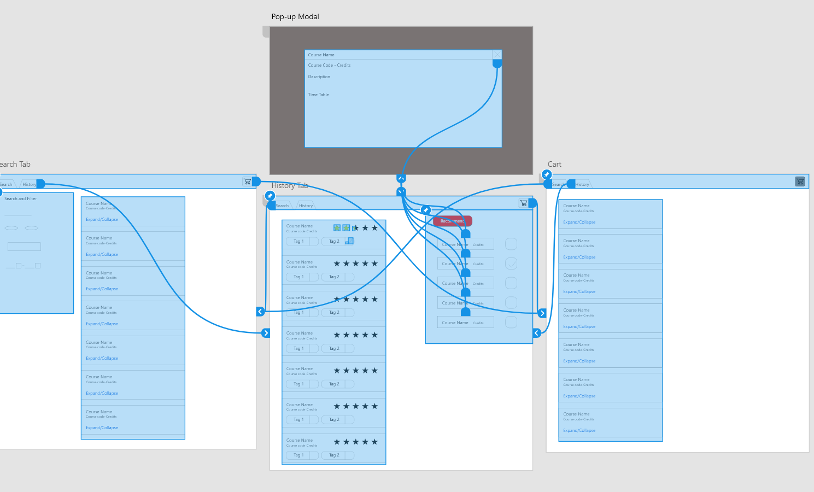

**Step 2. Review the Heuristics.** Review the ten usability heuristics we discussed in class from the slides, what principle each heuristic represents, and examples of the designs that violate and support the heuristics. Below is a cheat sheet for the Nielsen’s ten heuristics that you can use in the next step. (This step does not have any deliverables.)

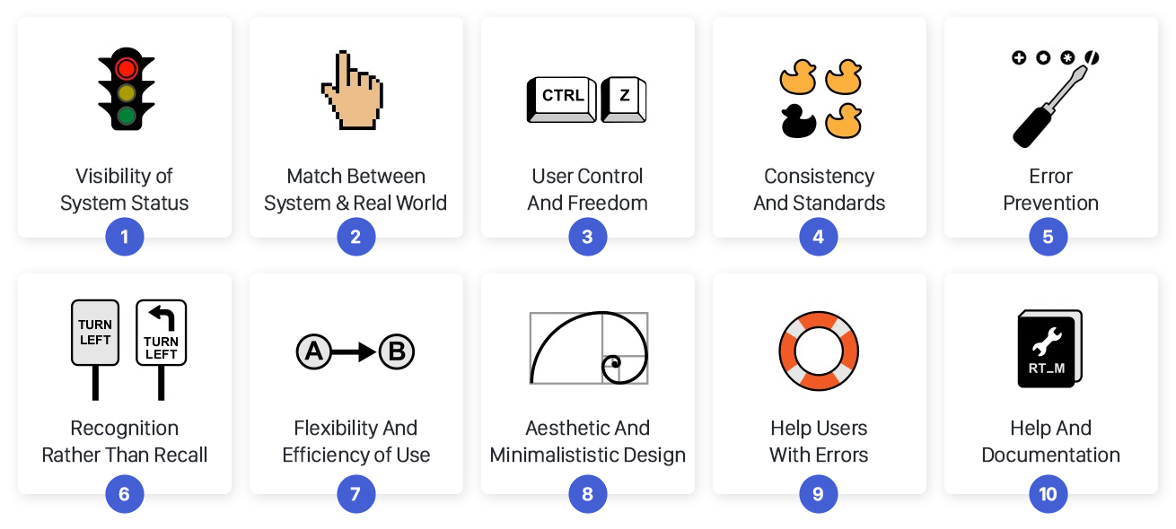

Image source: [UX Collective](https://uxdesign.cc/10-usability-heuristics-every-designer-should-know-129b9779ac53)

**Step 3. Identify Potential Violations.** Focusing on 2–3 key design elements of your prototype, inspect your design, considering each usability heuristic, for any violations of the heuristics. For each violation, use the following table to briefly describe the violation and give it a number. Make copies of your screenshots from Step 1, focusing on the design elements you are considering in this step, and mark them with the numbers so that the reader of your report can find the location of the violation in the screenshots and read your description in the table below. Color-code the violations for severity, using red (4), orange (3), yellow (2), green (1), and gray (0) for the severity-rating scale we covered in class.

|  |  |  |  |  |  |  |
| --- | --- | --- | --- | --- | --- | --- |
| **Heuristic** | **#** | **Design element 1** | **#** | **Design element 2** | **#** | **Design element 3** |
| *Visibility of system status* |  | 0 |  | 0 |  | 0 |
| *Match between real world & system* |  | 0 |  | 0 |  | 0 |
| *User control & freedom* |  | 0 |  | 0 |  | 3 |
| *Consistency & standards* |  | 0 |  | 0 |  | 0 |
| *Error prevention* |  | 0 |  | 0 |  | 0 |
| *Recognition rather than recall* |  | 0 |  | 0 |  | 0 |
| *Flexibility & efficiency of use* |  | 0 |  | 0 |  | 0 |
| *Aesthetic & minimalist design* |  | 0 |  | 0 |  | 0 |
| *Help users with errors* |  | 0 |  | 0 |  | 0 |
| *Help & documentation* |  | 0 |  | 4 |  | 2 |

<screenshots-marked-with-numbers>

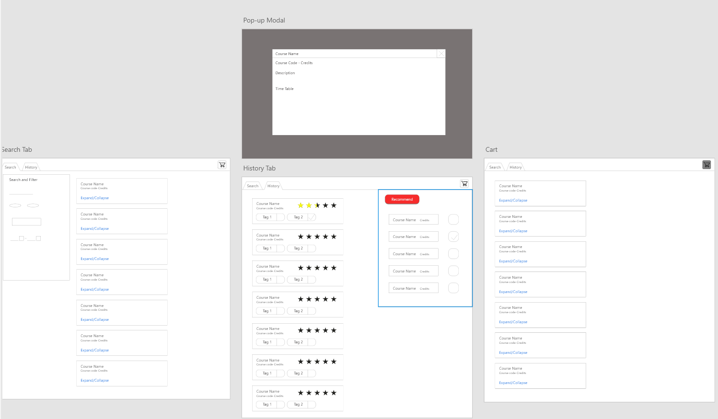

3

2

1

**Step 4. Develop Design Recommendations.** For each violation you identified in the previous step, provide a design recommendation for addressing it along with an indication of whether or not it is feasible to implement the recommendation in your prototype. (Only recommendations that are beyond the capabilities of Adobe XD or beyond the scope of the project should be marked as not being feasible.) Rank the recommendations based on the severity of the usability problem, from most severe to least severe. Use the table below for the recommendations, adding additional rows as needed, and follow the same color-coding from the previous step for severity ratings.

|  |  |  |
| --- | --- | --- |
| **#** | **Recommendation** | **Feasibility (Yes/No)** |
| 2 | Include a visual tutorial if the user first using it, indicate somewhere that the ratings are used for recommendation | NO/YES |
| 3 | When user click recommend, ask for confirmation before recommendation | YES |
| 3 | Same with design element 2, document what the checkbox is for | YES |

**Step 5. Update your Design.** In this step, you will implement the design recommendations that you identified as “feasible” in the previous step in your prototype, updating your design. Provide a link to the live Adobe XD prototype below and a paragraph that summarizes the outcome of the heuristic evaluation. Reflect on how your design improved, what you learned about usability in the process of applying the heuristics, and whether you gained any unexpected insights about your design.

<link-to-Adobe-XD-prototype>

<https://xd.adobe.com/spec/3572f788-2f0c-4d9b-725f-629709592909-4343/>

<summary-of-evaluation>

After the heuristic evaluation, my application design had improved in clarity. Before, you can click the ratings and tags, but you wouldn’t know what it does, only I, the designer, would know. Thus, using the heuristic evaluation allows me to think more about the user side of things, as certain things which may be clear for me may not be clear for the user. Thus, the evaluation teaches me to not assume what the user may or may not know, but to include texts and prompts for clarity and user control.